**Agricultural Robot Using Solar Energy**

Radhika Parkhi 1, Nirmayee Vilekar 1, Aarti Ambekar 2

1. U.G. student, Electronics and Telecommunication Department, DJSCOE, Vile-Parle (W), Mumbai –400056.

2. Asst. Professor, Electronics and Telecommunication Department, DJSCE, Vile-Parle (W), Mumbai – 400 056.

***Abstract:* About 70% of Indian GDP is dependent on agriculture. This paper presents a system for advanced agricultural techniques which includes cultivation of crops based on a platform which uses robotic techniques. The result of implemented model is also presented. The primary aim of this paper is to highlight the on-going trends in the field of farm robotics. Different implementations and applications of automatic movable systems and robotic arms in agriculture are studied .Our main aim is to implement a basic Prototype- Multi Purpose Agro-Robot. This bot can perform the different tasks. The aim is to develop a robot vehicle which put seeds and reap crops. Thus sowing of seeds and harvesting are the main functions of this project. It will reduce the farmer’s efforts to a great extent.**

**Key Words: Arduino Uno, Harvesting Mechanism, Seed sowing.**

**I INTRODUCTION**

Automation is required in farms as farms increase in size. Hence, it becomes difficult for the farmers to handle the whole hectare of land. Automation in agro-industry will reduce the efforts of farmers thus increasing the produce which will further help in increasing the GDP of our country. The use of robots is a rather new development as most of the existing solutions for automatic supervision, is designed for standard farm equipment. These tasks are perfectly suited for autonomous robots, as they often require numerous repetitions over a long period of time and over a large area. A robot is a machine that can be programmed and reprogrammed to do certain tasks and usually consists of tools attached to a mobile body or a stationary platform. The robotic system is moved by a DC motor. The machine consists of a panel which traps the solar energy that is used for charging the battery. This battery uses DC. The arduino is used to increase or decrease thus controlling and monitoring the process of movement of a robot or vehicle with the use of a DC motor.

**II LITERATURE SURVEY**

Design And Implementation of Seeding Agricultural Robot- Journal of Innovative Research and Solutions (JIRAS) A unit of UIIRS.

In Design and Implementation of Seeding Agricultural Robot, the controlling of processes using Atmega 328 was discussed. Water sprinkling and sowing was done using the Atmega 328 which is also known as Arduino. Interfacing of motors to Atmega 328 was also discussed.

In Robotic Agriculture Machine direction is provided to the robot using remote control. By using remote proper direction is given to the robot as the farm is not the straight

line and smooth. Hence using RF the vehicle can be controlled. Also, the Solar panel was explained. The working principle of all today solar cells is essentially the same. It is based on the photovoltaic effect. In general, the photovoltaic effect means the generation of a potential difference at the junction of two different materials in response to visible or other radiation.

In Agribot: An Agriculture Robot, the use of DC motors and motor drivers was explained. DC motors are used to physically drive the application as per the requirement provided in software. To drive a dc motor, we need a dc motor driver called L293D. This dc motor driver is capable of driving 2 dc motors at a time. In order to protect the dc motor from a back EMF generated by the dc motor while changing the direction of rotation, the dc motor driver has an internal protection suit. The L293D is a DC motor driver which is monolithic integrated high voltage, high current four channel driver designed to accept standard DTL or TTL logic levels and drive inductive loads such as relays, DC motors and switching power transistors.

In Multipurpose agricultural robot, the representation of the seed sowing mechanism using a shaft was implemented. A sheet metal box is used for Seed storage. It has 3 holes to the main wheel shaft, where the storage box is placed above it. The main wheels are powered by DC motor and are controlled by a remote controller. As the motor is switched on, the wheels tend to rotate and rotation of shaft makes the seeds fall on the cultivated field

**III BACKGROUND**

**1. Solar Panel:** It works on solar energy which is trapped from the sun. The solar cells depend on the photovoltaic effect. A solar cell is used to convert the light energy directly into electricity. This process is seen in silicon which requires that a material should absorb the solar energy, and then raise the electron to a higher energy level, leading flow of this high-energy electron to an external circuit**.**

**2. Photovoltaic effect:** The light-generated carrier cannot lead to power generation. The generation of voltage as well as a current is a must to generate solar power. Voltage generation in a solar cell takes place by a process which is known as the photovoltaic effect. This light generated carrier is the main cause of photovoltaic effect. The difference in potential at two junctions causes this effect.

**3. Arduino UNO**: Arduino is an Italian open-source computer hardware and Software Company as well as a project and user community that is used to design and manufacture project kits for building of digital and interactive devices and objects that can sense and control the physical world. The arduino can be installed with code and thus it can prove to be a very helpful device for robotics as well as for advanced sensor based projects. Due to its ease of use arduino is thus deployed in artificial intelligence projects as well. The typical arduino board is as shown in the figure below which includes of various mounted components such as IC and ports for external connections. All these components are mounted on the arduino.

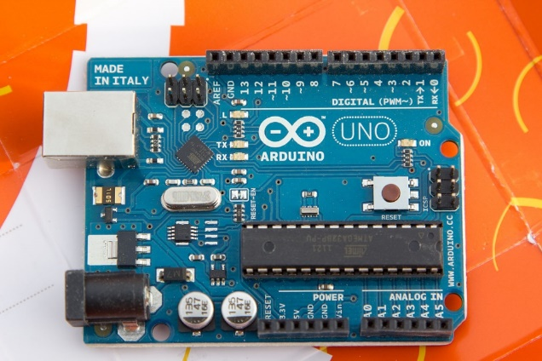

Fig 1.Arduino Uno [5]

**4. Radio Frequency Controller:** An RF controller is an electronic module which is used to both transmit as well as receive radio signals between any two devices. In embedded systems, it is usually desirable that interaction with a remote device takes place wirelessly. This type of wireless communication can be achieved through the use of radio frequency (RF) communication. For numerous applications priority is given to RF since it does not require LOS (line of sight). RF communications consist of a transmitter or receiver. An RF transmitter module is a small PCB subassembly which has the ability for transmission of a radio signal and modulating the signal to carry data. The transmitter modules are normally implemented along with a microcontroller thus it will enable provision of data for the module which can thus be transmitted. An RF receiver receives the modulated signal which is RF signal thus demodulating it. There are two categories of Radio Frequency receiver modules: super heterodyne receivers and super-regenerative receivers. Super-regenerative modules are the low cost and low power type devices using a number of amplifiers which are used to extract the modulated data from a carrier wave. Super- regenerative modules are not precise as their frequency changes considerably with temperature as well as with voltage. Super heterodyne receivers have an advantage over super-regenerative, they offer high accuracy, precision and stability over a large voltage and temperature range.

**IV WORKING**

**1. Seed Sowing Mechanism:** The seed sowing mechanism consists of a container with motor which is attached to the bottom of the vehicle. It has a shaft which rotates 360 degree. The shaft moves due to the motor. We have to add seeds in the container. The container has holes. The seeds will be sown in the ground from the holes

**2. Harvesting mechanism:** The RF automated harvesting robotic vehicle is powered by solar energy which helps in cutting the ready crops. It also has motor attached to it which helps in moving the blade so that the crops are cut efficiently without the requirement of any human interaction. The system uses batteries to power the vehicle for movement of motors as well as the cutting motor. We use a solar panel to charge the battery hence there is no need of charging it using to external source. The harvesting mechanism and all the vehicle motors are interfaced to an Arduino microcontroller that is used to control the working of all the motors.

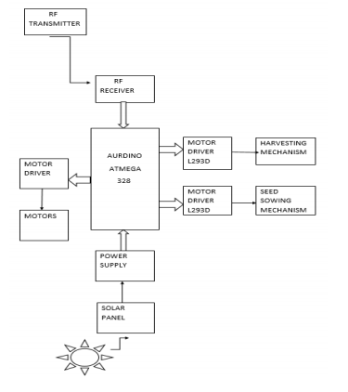

Fig 2.Block Diagram

**3. Path controlling of vehicle:** We can move the wheels in clockwise and anticlockwise direction by approximate coding in arduino. When there is a no potential difference between the two terminals of the motor, then the motor comes to a halt. When there is a potential difference between the two terminals of the motor, then the motor starts to move.

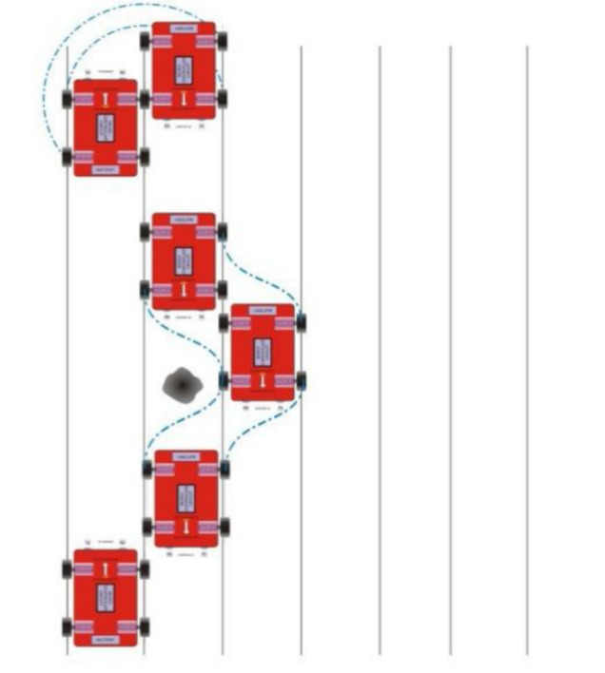

Fig 3.Path Controlling [2]

**V FUTURE SCOPE**

This system can be improved for sowing seeds in farmlands with a specific fixed distance between each seed. It can provide water supply by using a sprinkler. It can be useful as a system for fertilizer spraying. The system can be altered by monitoring through a GSM system.

**VI RESULT**

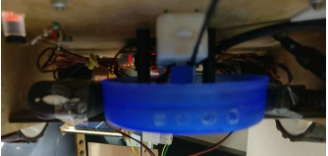

Fig 4. Seed Sowing

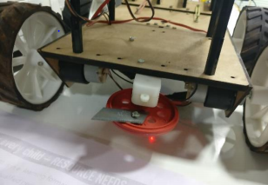

Fig 5. Harvesting Mechanism

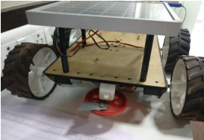

Fig 6. Model

**CONCLUSIONS**

Set out a vision of how aspects of crop production and harvesting could be automated. .Human efforts can be greatly reduced. Manufacturing costs are reduced because of bulk production. Solar energy reduces the wastage of natural resources. Time required for harvesting can be reduced.

**REFERENCES**

[1] Design and Implementation of Seeding Agricultural Robot- Journal of Innovative Research and Solutions (JIRAS) A unit of UIIRS.

[2] Robotic Agriculture Machine- International Journal of Innovative Research in Science, Engineering and Technology An ISO 3297: 2007 Certified Organization Volume 3, Special Issue 4, April 2014.

[3] Agribot: An Agriculture Robot-International Journal of Advanced Research in Computer and Communication Engineering Vol. 4, Issue 1, January 2015 Copyright to IJARCCE DOI 10.17148/IJARCCE.2015.4173 317

[4] Multipurpose agricultural robot-International Journal of Engineering Research ISSN: 2319- 6890) (online), 2347-5013(print) Volume No.5 Issue: Special 6, pp: 1129 - 1254 20 May 2016.

[5] Upload.wikimedia.org

[6] Directindustry.com